An Open Letter to Patient Safety Organizations and Providers

URAC announces recognition of the Patient Safety and Quality Improvement Act (P.L. 109-41), which extends protections to providers reporting patient safety events through a Patient Safety Organization (PSO) that is formally recognized by the Agency for Healthcare Research and Quality (AHRQ). As a result, URAC’s experience as an independent accrediting body can be utilized by both clinicians and entities seeking quality improvement assistance without impact on their accreditation status. Full details are described below.

This letter publicly informs providers that URAC fully complies with the protections outlined in the final rule implementing the Patient Safety and Quality Improvement Act.

Section 3.206(b)(8) of the Patient Safety and Quality Improvement Act requires the following:

- Accrediting bodies are prohibited from taking an accrediting action against a provider based on the good faith participation of the provider in the:
  - collection,
  - development,
  - reporting, or
  - maintenance of patient safety work product that is prepared and reported to any recognized PSO.

• Patient safety work products that have been reported by a provider through a recognized PSO and are voluntarily shared with an accrediting body must address the identities of non-disclosing providers by either:
  - Obtaining the agreement of non-disclosing providers to the disclosure of the patient safety work product; or
  - Anonymizing the patient safety work product with respect to the identity of non-disclosing providers identified in the work product.

Further, the Patient Safety and Quality Improvement Act prohibits an accrediting body such as URAC from requiring a provider to disclose patient safety work product. Nor can an accrediting body take any specific accrediting action against a provider who refuses to disclose patient safety work product to the accrediting body.

Best regards,

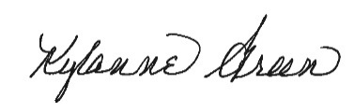

Kylanne Green
President and Chief Executive Officer

